Department of Artificial Intelligence
22AIE312: Big Data Analytics
Cryptocurrency Network Forensics using Ethereum Blockchain Transactions


SUBMITTED BY
GROUP D05
Rangala Karthikeya CB.SC.U4AIE23333
Tanguturi Vinay Krishna Chetty CB.SC.U4AIE23341
Katikala Dedeepya CB.SC.U4AIE23349
Gutta Karthikeya CB.SC.U4AIE23358
Supervised By:
Dr. P. Adra
Assistant Professor
Centre for Computational Engineering and Networking
AMRITA SCHOOL OF ARTIFICIAL INTELLIGENCE
AMRITA VISHWA VIDYAPEETHAM COIMBATORE - 641 112 (INDIA)
March – 2026
AMRITA VISHWA VIDYAPEETHAM- COIMBATORE CERTIFICATE
This is to certify that this project entitled, “Cryptocurrency Network Forensics using Ethereum Blockchain Transactions” submitted by Rangala Karthikeya, Tanguturi Vinay Krishna Chetty, Katikala Dedeepya and Gutta Kathikeya is an authentic work carried out by the team under my supervision and guidance. To the best of my knowledge, the content presented in this report has not been previously submitted to any other academic institution, nor has it been utilized to fulfill any degree or diploma.
Date:04-03-2026
Dr. P. Adra
Dept. of Artificial Intelligence Amrita Vishwa Vidyapeetham
Coimbatore- 641112

ACKNOWLEDGEMENT
We express our sincere gratitude to Dr. K P Soman, the Dean of our department who gave us this opportunity to do this extremely good project on the topic “Cryptocurrency Network Forensics using Ethereum Blockchain Transactions”. This project helped us to learn and understand many new concepts and learn new things related to Artificial Intelligence in Big Data Analytics, Cryptocurrency and Machine Learning. Our heartfelt thanks to our project guide Dr. P.Adra mam for her patience and dedication in guiding us at every step of the project. Her knowledge and very valuable insights have been very helpful in successfully completing the project. We consider ourselves fortunate to have the opportunity to work under their guidance and extend our sincere thanks for their support and encouragement, without which this project would not have been possible.

TABLE OF CONTENT
1. INTRODUCTION ………………………………………………………………. 05
2. ABSTRACT……………………………………………………………………… 06
3. OBJECTIVE……………………………………………………………………… 07
4. LITERATURE SURVEY………………………………………………………… 08
5. RESEARCH GAP AND NOVELTY…………………………………………….. 10
6. DATASET DESCRIPTION……………………………………………………… 12
6.1. Source and format…………………………………………….
6.2 . Time coverage………………………………….......................
6.3. Blocks dataset…………………………………………………
6.4. Transaction dataset……………………………….....................
6.5. Dataset characteristics…………………………………………
6.6. Usefulness ……………………………………………………
6.7. Reference link………………………………………………...
7. METHODOLOGY……………………………………………………………….. 15
- Data collection and ingestion………………………………………
- Data storage and preprocessing…………………………………….
- Feature engineering…………………………………………………
- Exploratory Data Analysis………………………………………….
- Rule based anomaly detection………………………………………
- Machine learning based anomaly detection………………………...
- Graph based network analysis………………………………………
- Time series and temporal analysis………………………………….
- Visualizations and interpretation……………………………………
8. BIG DATA TOOLS AND ANALYTICS FRAMEWORK ……………………….. 19
9. 5V’S OF BIG DATA ……………………………………………………………… 20
10. DETECTIONS AND ANALYTICS PERFORMED ……………………………. 22
10.1. Transaction level analytics…………………………………………….
10.2. Wallet level behavioral analysis……………………………………….
10.3. Temporal and time series analysis……………………………………..
10.4 unsupervised machine learning based detection………………………..
10.5. Deep learning based anomaly detection……………………………….
10.6. Graph based network analysis…………………………………………
10.7. Detected anomaly categories…………………………………………..
11. RESULTS AND DISCUSSION…………………………………………………. 23
12. FUTURE WORK………………………………………………………………… 31
13. CONCLUSION…………………………………………………………………... 32
14. REFERENCES…………………………………………………………………… 32
15. APPENDIX……………………………………………………………………….

- INTRODUCTION
Blockchain technology has revolutionized the way decentralized financial systems operate by enabling transparent, immutable, and trustless transactions. Among various blockchain platforms, Ethereum has emerged as one of the most widely used ecosystems, supporting smart contracts, decentralized applications (DApps), decentralized finance (DeFi), and non-fungible tokens (NFTs). As Ethereum processes millions of transactions daily, it generates massive volumes of data that require scalable and efficient analysis techniques.
Despite its transparency, the Ethereum blockchain is vulnerable to various forms of malicious activities and anomalous behaviors, such as bot-driven transactions, wash trading, smurfing, zero-value transaction spam, and market manipulation strategies like pump-and-dump schemes. These activities can distort transaction statistics, mislead investors, increase network congestion, and undermine trust in decentralized systems. Traditional data processing and fraud detection methods are inadequate for handling the scale, velocity, and complexity of blockchain data.
This project focuses on building a Big Data–driven anomaly detection and analytics system for Ethereum blockchain transactions. The system leverages Apache Spark and distributed data processing techniques to efficiently handle large-scale blockchain datasets stored in Parquet format. By using PySpark, the project performs high-performance data ingestion, cleaning, transformation, and aggregation across millions of transaction records.
To effectively identify suspicious behaviors, the project adopts a multi-layered analytical approach. Rule-based detection techniques are used to capture known fraud patterns such as bot activity, smurfing wallets, and zero-value transaction flooding. In addition, machine learning–based anomaly detection models, including Isolation Forest and Autoencoders, are employed to detect previously unknown or subtle anomalies that cannot be identified using fixed thresholds alone.
Furthermore, the project incorporates graph-based network analysis, where Ethereum wallets are modeled as nodes and transactions as edges. This enables the detection of complex behaviors such as circular fund transfers, wash trading, and coordinated wallet interactions. Time-series analytics is also applied to transaction volume and value trends to identify pump-and-dump patterns, which are indicative of market manipulation.
The results of the analysis are presented through comprehensive visualizations and analytical dashboards, allowing clear interpretation of detected anomalies and fraud patterns. The final system provides actionable insights by classifying wallets and blocks into normal and suspicious categories, thereby supporting blockchain monitoring, fraud investigation, and regulatory analysis.
Overall, this project demonstrates how Big Data analytics, machine learning, and network analysis can be integrated to build a scalable, intelligent, and real-world blockchain anomaly detection system capable of handling the challenges posed by modern decentralized financial ecosystems.
- ABSTRACT
The rapid growth of blockchain technology has led to an unprecedented increase in transaction volume, making effective monitoring and analysis of blockchain networks a critical challenge. Ethereum, as one of the most widely adopted blockchain platforms, generates massive transactional data that is difficult to process using traditional analytical methods. Moreover, the open and decentralized nature of Ethereum makes it susceptible to various anomalous and fraudulent activities, including bot-driven transactions, wash trading, smurfing, zero-value transaction spam, and market manipulation schemes such as pump-and-dump events.
This project presents a scalable Big Data–based framework for detecting and analyzing anomalous behavior in Ethereum blockchain transactions. The system utilizes distributed data processing using Apache Spark and PySpark to efficiently ingest, clean, and process large-scale blockchain datasets stored in Parquet format. Meaningful transaction-, wallet-, and block-level features are engineered to capture behavioral patterns across the network.
A multi-dimensional analytical approach is adopted, combining rule-based detection methods, machine learning–based anomaly detection models such as Isolation Forest and Autoencoders, graph-based network analysis, and time-series analytics. This integrated methodology enables the identification of both known fraud patterns and previously unseen anomalies. Visualization techniques are employed to interpret analytical results and present insights in an intuitive manner.
The proposed system successfully identifies suspicious wallets, anomalous blocks, and potential market manipulation activities, demonstrating the effectiveness of Big Data analytics and machine learning in blockchain fraud detection. This work highlights the practical applicability of scalable analytical frameworks for enhancing transparency, security, and trust in decentralized financial ecosystems.
- OBJECTIVES
The primary objective of this project is to design and implement a scalable Big Data analytics system for detecting anomalous and fraudulent activities in Ethereum blockchain transactions. The specific objectives of the project are as follows:
To collect and manage large-scale Ethereum blockchain data
- To obtain Ethereum block and transaction data available in Parquet format.
- To handle the high volume, velocity, and variety of blockchain data.
- To organize and store the data efficiently for large-scale analysis.
To perform distributed data ingestion and processing
- To load blockchain data into distributed DataFrames.
- To process millions of transaction records efficiently.
- To leverage Apache Spark and PySpark for parallel data processing.
To engineer meaningful analytical features
- To extract transaction-level features such as transaction value, gas usage, and success status.
- To derive wallet-level behavioral features such as transaction frequency, total inflow/outflow, and failure rate.
- To compute block-level metrics including block size and transaction density.
- To transform raw blockchain data into structured features suitable for analytics and modeling.
To detect known fraudulent patterns using rule-based techniques
- To identify bot-like wallets based on unusually high transaction frequency.
- To detect smurfing behavior involving splitting transactions across multiple wallets.
- To identify wash trading patterns through repetitive circular transfers.
- To detect zero-value transaction spam commonly used for network manipulation.
To identify unknown anomalies using machine learning models
- To apply unsupervised machine learning techniques such as Isolation Forest and Autoencoders.
- To detect abnormal wallet and transaction behavior without labeled data.
- To complement rule-based detection with intelligent anomaly detection methods.
To perform graph-based transaction network analysis
- To represent Ethereum transactions as a graph of wallets and fund transfers.
- To analyze wallet interaction patterns to identify circular flows and coordinated behavior.
- To uncover complex fraud patterns that are not visible through individual transactions.
To analyze temporal behavior and market manipulation
- To perform time-series analysis on transaction volumes and values.
- To detect sudden spikes or drops indicating pump-and-dump activity.
- To study how anomalous behavior evolves over time on the blockchain.
- LITERATURE SURVEY
Ethereum blockchain networks create huge amounts of transaction data which cybercriminals increasingly use to conduct fraudulent activities and execute their anomalous schemes. Multiple research studies have investigated three areas of study on Ethereum through their implementation of graph-based approaches and machine learning methods and deep learning techniques. The section presents five important research studies which connect to this project while showing the research gap that the proposed system will address.
A. Behavior-aware Account De-anonymization on Ethereum Interaction Graph (2022)
Wu et al. [1] created a behavior-aware system which enables Ethereum account de-anonymization through the observation of user interaction patterns. The authors developed an Ethereum Account Interaction Graph (AIG) which uses accounts as nodes and transaction connections as edges. The researchers utilized a hierarchical graph attention encoder for acquiring behavioral patterns through multiple research stages. The researchers used contrastive self-supervised learning to solve their issue of not having enough labeled data.
The system successfully determines account identities through user interaction patterns. However, the system concentrates on de-anonymization instead of detecting fraudulent activities and abnormal events. The proposed project uses graph-based concepts as a secondary element which helps identify harmful activities that include bot operations wash trading smurfing and pump-and-dump schemes through graph analysis combined with big data processing and machine learning and time-series analytical methods.
B. Blockchain-based Fraud Detection: A Systematic Review of Ethereum Network Applications (2025)
The researchers analyzed Ethereum network fraud detection methods through their systematic review which Patel et al. [2] conducted. The study analyzed various machine learning and deep learning approaches, including Random Forest, Support Vector Machines, XGBoost, and neural networks. The review compared datasets, feature engineering techniques, evaluation metrics, and reported accuracies across multiple studies.
The paper presents an extensive overview of current methods but it does not develop or test a detection system. Most of the studied research works use small datasets which contain labeled data. The proposed project addresses these limitations by implementing an end-to-end scalable analytics pipeline using real Ethereum blockchain data and unsupervised anomaly detection and distributed processing.
C. Aparecium: Detecting Scam Behaviors on Ethereum via Biased Random Walk (2023)
The researchers Zhang et al. [3] created Aparecium, which serves as a graph-based scam detection system that detects scams on the Ethereum blockchain. The researchers created a transaction graph which represented fraudulent activities and they used biased random walk sampling to maintain the special structural patterns that exist for scams. The researchers used graph-derived features to train machine learning classifiers which successfully detected scam-related addresses.
The system successfully detects fraudulent activities but it only operates using specific scam detection methods and graph-based characteristics. The proposed project extends beyond scam detection by identifying multiple anomaly types, including bot activity, smurfing, wash trading, and abnormal transaction bursts, using a combination of rule-based logic, machine learning, and time-series analysis.
D. Detection of Fraudulent Transactions in Ethereum Blockchain Smart Contracts Using Deep Learning (2025)
Kumar et al. [4] developed a deep learning fraud detection system which detects fraudulent activities in Ethereum smart contracts. The model combines Jaya-based feature selection with a deep neural network (FTDNet) to classify fraudulent and legitimate transactions. The approach achieved high accuracy on labeled benchmark datasets.
The model demonstrates strong performance because it requires labeled datasets to function while it processes smart contract transactions. The proposed project uses unsupervised anomaly detection techniques which include Isolation Forest and Autoencoders to identify unknown fraud patterns that occur in all Ethereum transactions without needing labeled data.
E. Intelligent Fraud Detection in Ethereum Transactions Using Machine Learning (2025)
Reddy et al. [5] examined traditional machine learning models like Random Forest, XGBoost, and Support Vector Machines to classify Ethereum transactions as either fraudulent or normal. The study focused on transaction-level features such as gas usage, transaction value, and timestamp.
While this approach shows good classification performance, it has limitations due to the assumptions of supervised learning and does not tackle scalability. The proposed project improves on this by processing large blockchain data using Apache Spark. It also includes wallet-level and block-level behavioral features and uses unsupervised and graph-based analytics to identify complex fraud patterns.
5. RESEARCH GAP AND NOVELTY
5.1. Research Gap
Despite extensive research on fraud and anomaly detection in the Ethereum ecosystem, several critical gaps remain in existing literature:
- Limited Scalability to Real-World Blockchain Data: Most existing studies evaluate their models on small, curated, or labeled datasets. These approaches do not scale effectively to real Ethereum transaction volumes that involve millions of records. This limits their use in real-world blockchain monitoring systems.
- Dependence on Supervised Learning and Labeled Data: A significant portion of prior work relies on supervised machine learning or deep learning models that require labeled fraud datasets. However, labeled blockchain fraud data is scarce, incomplete, and often outdated. This makes supervised approaches impractical for detecting newly emerging fraud patterns.
- Single-Dimensional Detection Approaches: Many studies focus on one analytical dimension, such as graph analysis, transaction classification, or smart contract inspection. Such isolated approaches fail to capture the complex nature of blockchain fraud, which often spans wallet behavior, transaction flow, time trends, and network structures at the same time.
- Narrow Focus on Specific Fraud Types: Existing works typically address specific fraud categories, such as scam detection, smart contract vulnerabilities, or account de-anonymization. This leaves a gap in detecting different types of anomalies, such as bot-driven transactions, smurfing, wash trading, zero-value transaction spam, and market manipulation within a unified framework.
- Lack of Integrated Time-Series and Behavioral Analysis : Although some studies analyze transaction graphs, they often ignore time dynamics, such as sudden spikes in transaction volume or coordinated activity over time. These are crucial indicators of pump-and-dump schemes and coordinated fraud.
5.2. Novelty of the Project
To address the research gaps mentioned, this project presents the following new contributions:
- Scalable Big Data-Driven Architecture : The project sets up a fully scalable analytics pipeline using Apache Spark. This allows for efficient processing of large Ethereum blockchain datasets stored in Parquet format. As a result, the system operates on real-world data volumes instead of sampled datasets.
- Unsupervised Anomaly Detection Without Labeled Data : Unlike current supervised methods, the proposed system uses unsupervised machine learning models like Isolation Forest and Autoencoders. This allows it to detect new and changing fraud patterns without relying on labeled training data.
- Multi-Dimensional Fraud and Anomaly Detection Framework : The project combines rule-based detection, machine learning-based anomaly detection, graph-based network analysis, and time-series analytics into one framework. This comprehensive approach captures behavioral, structural, and temporal anomalies at the same time.
- Behavior-Driven Feature Engineering Across Multiple Levels : New wallet-level, transaction-level, and block-level behavioral features are created, including transaction frequency, gas usage patterns, wallet failure rates, circular fund flows, and bursts of transactions over time. These features provide better indicators of anomalies than raw transaction data.
- Comprehensive Detection of Diverse Anomaly Types : The proposed system detects more than just scams or smart contract fraud. It identifies a wide range of anomalies, including:
  - Bot-driven transaction behavior
  - Smurfing and fund-splitting activities
  - Wash trading and circular transfers
  - Zero-value transaction spam
  - Pump-and-dump and market manipulation patterns
- Explainable and Interpretable Analytical Insights: By using visualization techniques like time-series plots, behavioral distributions, and transaction graphs, the system offers understandable results. This helps analysts grasp why a wallet or block is considered suspicious.
6. DATASET DESCRIPTION — Ethereum_blockchain_parquet
The dataset for this project, called “Ethereum_blockchain_parquet,” is hosted on Hugging Face. It includes real-world blockchain data from the Ethereum network in columnar Parquet format. This format allows for efficient analysis using tools like Apache Spark .
6.1. Source and Format
Source: Hugging Face dataset repository: vnegi10/Ethereum_blockchain_parquet .
Data format: Apache Parquet, a columnar storage format designed for big data tasks.
Total Size: About 20.9 GB of Parquet files
License: GPL-3.0 open-source license.
Data modality: Tabular blockchain data.
Tools supported: Spark, Dask, Polars, pandas (for sampled data).
The dataset consists of two main components:
  - blocks
  - transactions
6.2. Time Coverage
The dataset covers a significant period in Ethereum’s history, including blocks from about November 17, 2016, to March 25, 2025. This timeframe allows analysis of blockchain behavior over several years, including major network events, hard forks, market cycles, and unusual transaction spikes.
6.3. Blocks Dataset
The blocks directory contains Parquet files with the following schema:
Column | Type | Description
block_hash | Binary | 32-byte Keccak-256 hash identifying each block
author | Binary | Address of the block proposer/miner
block_number | UInt32 | Block height in the chain
gas_used | UInt64 | Total gas consumed by transactions in the block
extra_data | Binary | Additional metadata from miner
timestamp | UInt32 | Unix epoch time of block creation
base_fee_per_gas | UInt64 | Base gas fee (introduced with EIP-1559)
chain_id | UInt64 | Chain identifier (e.g., 1 for Ethereum Mainnet)

6.4. Transactions Dataset
The transactions directory contains transaction-level Parquet files with the following schema:
Column | Type | Description
block_number | UInt32 | Block containing the transaction
transaction_index | UInt64 | Index of transaction in block
transaction_hash | Binary | 32-byte transaction identifier
nonce | UInt64 | Sender’s sequential transaction count
from_address | Binary | Sender address
to_address | Binary | Recipient address
value_binary | Binary | Transaction value in wei (raw)
value_string | String | Human-readable string representation
value_f64 | Float64 | Floating-point value in wei
input | Binary | Calldata (used for smart contract calls)
gas_limit | UInt64 | Max gas allowed for the transaction
gas_used | UInt64 | Actual gas consumed
gas_price | UInt64 | Price per gas unit
transaction_type | UInt32 | Type (e.g., legacy or EIP-1559)
max_priority_fee_per_gas | UInt64 | Tip to miner
max_fee_per_gas | UInt64 | Max total fee willing to pay
success | Boolean | Whether the transaction succeeded
n_input_bytes | UInt32 | Length of input data
n_input_zero_bytes | UInt32 | Number of zero bytes in input
n_input_nonzero_bytes | UInt32 | Number of non-zero input bytes
chain_id | UInt64 | Chain ID of transaction

6.5.Dataset Characteristics
Large-scale: Over 94 million rows that cover a wide range of blocks and transactions .
Multi-year coverage: Captures Ethereum activity from 2016 to 2025.
Detailed transaction information: Includes both legacy and EIP-1559 transaction metrics .
Easily joinable: Blocks and transactions can be easily joined on block_number for combined analysis.
6.6. Usefulness for the Project
This dataset is essential for the project because it provides:
  - Block-level features for identifying congestion and anomalies.
  - Transaction-level features for analyzing behavior and modeling the network.
  - Wallet interaction patterns for detecting wash trading and performing graph analysis.
  - Success/failure signals used for calculating failure rates and scoring anomalies.
The dataset is suitable for applying rule-based detection, unsupervised machine learning models, network analysis, and time-series analysis, as carried out in this project.
6.7. REFERENCE AND LINK
[1] Hugging Face, “vnegi10/Ethereum_blockchain_parquet,” Hugging Face Datasets, 20.9 GB, Parquet tabular dataset. Available: https://huggingface.co/datasets/vnegi10/Ethereum_blockchain_parquet.
7. METHODOLOGY
The proposed system uses a clear and flexible method to detect anomalies and fraudulent behavior in the Ethereum network with Big Data analytics and machine learning. The overall workflow handles large-scale blockchain data. It extracts important behavioral features and identifies suspicious activities through various analytical techniques. The method is divided into the following phases.

A. Data Collection and Ingestion
The first stage focuses on collecting large amounts of data from Ethereum blockchain records. Public Ethereum block and transaction datasets, stored in Parquet format, are obtained from an open blockchain repository. These datasets provide detailed information such as block numbers, timestamps, gas usage, transaction values, sender and receiver addresses, and the status of transaction execution.
To handle large datasets effectively, the data is ingested using Apache Spark with PySpark. This distributed system allows for the parallel reading and processing of gigabyte-scale blockchain data across multiple partitions.
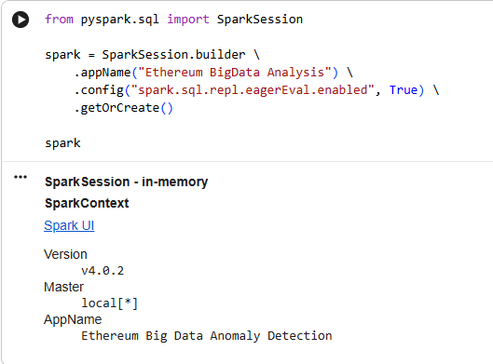
Fig 1: Spark Session Creation
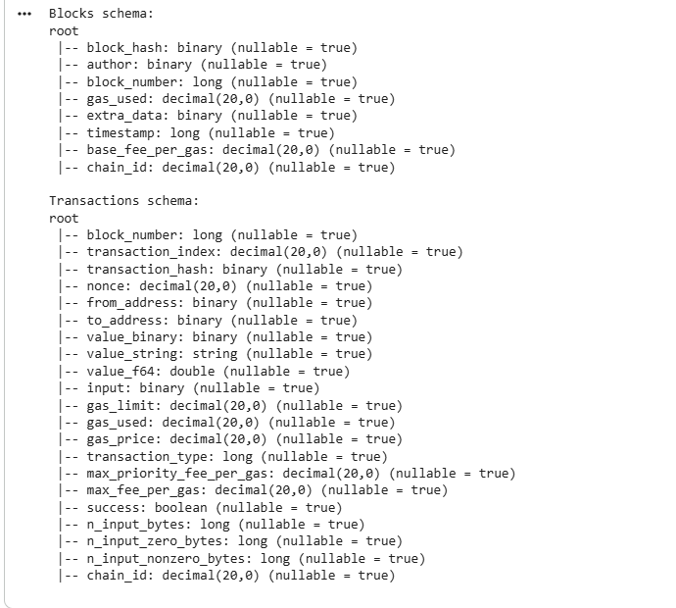
Fig 2: Data Ingestion
B. Data Storage and Preprocessing
The ingested datasets are stored in a Hadoop-style distributed file structure using Parquet, which offers efficient compression and column-based storage. During preprocessing, corrupt and incomplete records are ignored to keep the data reliable.
Data cleaning is performed to remove transactions that have missing or invalid values in important fields such as transaction value, gas limit, gas used, gas price, and wallet addresses. This ensures that the following analytical and machine learning models work with dependable and consistent data.
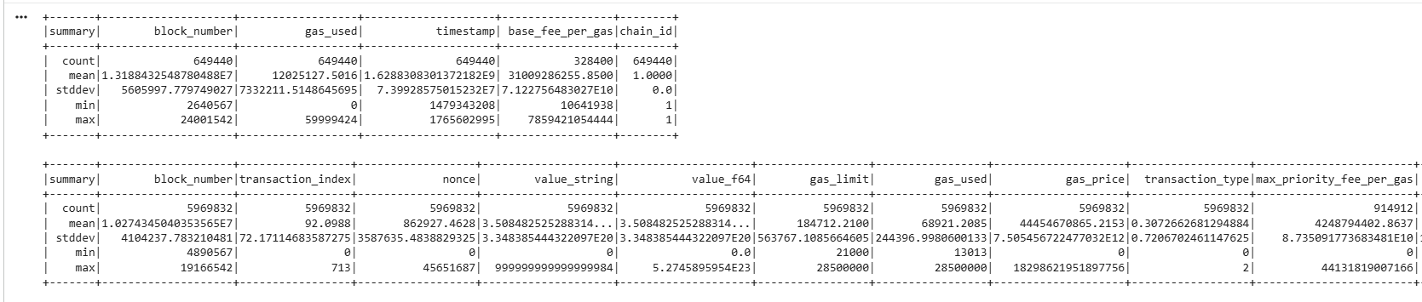
Fig 3: Data Storage
C. Feature Engineering
Feature engineering is important for spotting behavioral patterns in blockchain transactions. Features are created at three different levels:
Transaction-Level Features
  - Transaction value in ETH
  - Gas used and gas limit
  - Transaction fee
  - Transaction success or failure
Wallet-Level Features
  - Total transaction count
  - Average transaction value
  - Failure rate of transactions
  - Variance in gas usage
Block-Level Features
  - Average gas used per block
  - Block gas utilization
  - Base fee per gas
  - Number of transactions per block
These features enable profiling of wallet and block behavior instead of relying solely on raw transaction attributes.
D. Exploratory Data Analysis (EDA)
Exploratory Data Analysis helps understand the statistical and behavioral traits of Ethereum transactions. Techniques such as distribution analysis, scatter plots, and aggregation summaries are used to study transaction value distributions, gas usage patterns, transaction success rates, and block congestion levels.
EDA helps spot skewed distributions, unusual spikes, and inconsistent patterns, which can indicate abnormal behavior in the network.
E. Rule-Based Anomaly Detection
To identify known fraud patterns, rule-based heuristics apply blockchain behavior knowledge. This includes:
  - Bot detection, based on very high transaction counts with low transaction values.
  - Smurfing detection, where wallets make numerous small-value transactions.
  - Zero-value transaction detection, often linked to spam or probing activity.
  - Wash trading detection, seen in repeated transfers between wallet pairs.
These rules offer clear and understandable mechanisms for detecting anomalies.
F. Machine Learning-Based Anomaly Detection
To find unknown and changing fraud patterns, unsupervised machine learning models are used:
Isolation Forest
Wallet-level and block-level features train an Isolation Forest model, which identifies anomalies by separating them based on feature space. Wallets and blocks with unusual behaviour are flagged as suspicious without needing labeled training data.
Autoencoder-Based Detection
A neural network autoencoder is trained to recreate normal transaction behaviour. Wallets showing high reconstruction errors are marked as anomalous, indicating unusual patterns.
These unsupervised methods allow the system to discover new anomalies.
G. Graph-Based Network Analysis
Blockchain transactions are represented as a directed graph, with nodes as wallet addresses and edges as fund transfers. Graph analysis techniques are applied to:
  - Identify circular fund movements
  - Detect repeated sender-receiver interactions
  - Highlight coordinated transaction behavior
Graph-based visualization improves the understanding of suspicious wallet interactions.
H. Time-Series and Temporal Analysis
To capture time-related anomalies, transactions are grouped into fixed time windows. Rolling averages and indicators of deviation are calculated to spot sudden increases and decreases in transaction volume and ETH transfer amounts.
This helps detect pump-and-dump behaviors, where quick transaction surges are followed by sharp declines.
I. Visualization and Interpretation
A variety of visualization techniques are used to present results, including histograms, bar charts, scatter plots, time-series graphs, and transaction network graphs. These visual aids help analysts confirm anomalies and understand the behaviors of suspicious wallets and blocks.
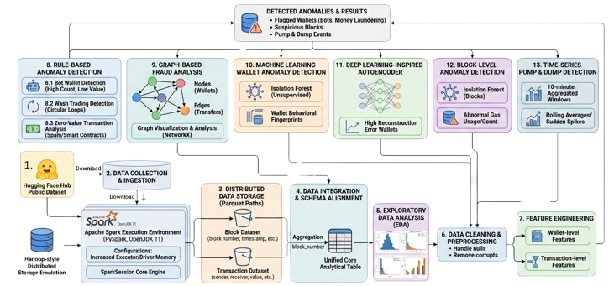
Fig 5: Block Diagram

8. BIG DATA TOOLS AND ANALYTICS FRAMEWORK
Tool / Technology | Description and Usage in the System
Apache Spark | Apache Spark is a distributed, in-memory Big Data processing framework designed for large-scale analytics. It supports parallel execution of transformations and actions across clustered environments. In this system, Spark enables efficient processing of large Ethereum blockchain datasets by performing aggregations, filtering, joins, and statistical computations on millions of transaction records with low latency.
PySpark | PySpark provides a Python interface to Apache Spark and allows seamless integration of blockchain data processing with Python-based analytics. Ethereum transaction and block data are loaded as Spark DataFrames, where preprocessing, feature extraction, temporal analysis, and rule-based anomaly indicators are computed at scale using distributed operations.
Hadoop-Style Storage (Parquet Format) | Parquet is a columnar storage format optimized for analytical workloads on large datasets. It supports compression, efficient encoding, and schema consistency. Ethereum blockchain data stored in Parquet format enables selective column reads and faster query execution, reducing I/O overhead during large-scale transaction analysis.
Hugging Face | Hugging Face Datasets provides a scalable and version-controlled platform for hosting large datasets. The Ethereum blockchain dataset is accessed directly in Parquet format, allowing seamless integration with Spark-based processing pipelines while ensuring reproducibility and consistency across analytical experiments.
Spark SQL | Spark SQL enables structured querying of blockchain data using SQL semantics on distributed DataFrames. It is used to generate analytical summaries such as high-frequency wallets, abnormal ETH flow patterns, and block-level statistics. The Catalyst optimizer enhances query execution efficiency for large-scale blockchain analytics.
NetworkX | NetworkX is a graph analytics library used to model Ethereum transactions as directed graphs, where wallets represent nodes and ETH transfers represent edges. Graph traversal and structural analysis techniques are applied to identify circular fund flows, wash trading behavior, and coordinated wallet activity indicative of fraudulent patterns.
Scikit-learn | Scikit-learn provides classical machine learning algorithms and preprocessing utilities. Engineered blockchain features are analyzed using unsupervised anomaly detection techniques such as Isolation Forest, enabling the identification of abnormal transaction and wallet behavior without requiring labeled fraud data.
PyTorch | PyTorch is a deep learning framework used to implement autoencoder-based anomaly detection models. The neural network learns normal transaction behavior patterns and flags anomalies based on reconstruction error. This approach captures complex and non-linear fraud patterns that may not be detected using traditional machine learning methods.

9. 5V’s OF BIG DATA
The Ethereum blockchain produces a huge amount of transaction and block data that displays the main features of Big Data. These features are usually described by the five V’s: Volume, Velocity, Variety, Veracity, and Value. The proposed system deals with each of these aspects by using scalable data storage, distributed processing, and data analysis.
A. Volume
The Ethereum network creates a very large amount of data because it continuously generates blocks and processes transactions. Each block includes multiple transactions, logs, and metadata, leading to datasets that consist of millions of records and several gigabytes of data.
The large amount of data requires distributed processing and effective storage solutions. Using columnar storage formats and in-memory computation tools allows the scalable management of blockchain data without slowing down performance.
B. Velocity
Data from the Ethereum blockchain comes in quickly, with new blocks added regularly and transactions happening all the time. This fast data generation needs analytical systems that can process and analyze data efficiently to spot unusual patterns quickly.
The project supports quick data processing by performing parallel computations and batch analytics. This setup helps in promptly identifying sudden spikes in transactions, unusual wallet activity, and coordinated fraud.
C. Variety
Blockchain data shows a lot of variety, containing different data types and structures. Ethereum data includes details about transactions (sender, receiver, value, gas), block information (block number, timestamp), smart contract interactions, and wallet behavior patterns.
The system processes both structured and semi-structured data, using schema-aware storage formats and adaptable analytical tools. This enables a unified analysis of various blockchain data components.
D. Veracity
Datasets from the blockchain can contain noise, duplicate transactions, failed transfers, zero-value transactions, and unusual activity that may affect analysis accuracy. Ensuring data reliability and consistency is crucial for effective anomaly detection.
To improve data quality and trustworthiness in analysis, the project uses preprocessing steps such as filtering out invalid transactions, managing missing values, normalizing numerical features, and checking schema consistency.
E. Value
The main goal of Big Data analytics is to gain valuable insights from raw data. In this project, value comes from transforming vast amounts of Ethereum transaction data into useful information related to fraud detection and anomaly recognition.
By using statistical analysis, machine learning, deep learning, and graph-based analytics, the system offers valuable insights into suspicious wallet behavior, coordinated fraud patterns, and unusual transaction trends. This supports better blockchain security and monitoring.

10. DETECTIONS AND ANALYTICS PERFORMED
The proposed system performs multi-level detection and analysis on Ethereum blockchain data. It identifies unusual and potentially fraudulent behavior. The analytics framework combines statistical methods, machine learning, deep learning, and graph-based techniques to capture various anomaly patterns within the Ethereum network.
10.1. Transaction-Level Analytics
Transaction-level analysis looks at individual Ethereum transactions to find abnormal patterns. We analyze statistical metrics like transaction value distribution, gas usage, and frequency to spot deviations from normal activity. Sudden spikes in transaction counts, repeated low-value transfers, and unusual gas consumption are flagged as potential anomalies.
10.2. Wallet-Level Behavioral Analysis
Wallet-level analytics compile transaction behavior over time to describe account activity. We calculate features like total incoming and outgoing ETH, transaction frequency, average transfer value, and time between transactions. Wallets showing unusually high activity, repetitive transfers, or unbalanced fund movement are considered suspicious.
10.3. Temporal and Time-Series Analysis
Temporal analytics examine time-related transaction patterns. We use block-wise and time-window-based aggregation to identify bursts of activity, sudden behavioral changes, and coordinated transaction sequences. Such time-based irregularities often suggest automated bot activity, pump-and-dump schemes, or organized fraud efforts.
10.4. Unsupervised Machine Learning-Based Detection
Unsupervised anomaly detection models analyze blockchain features to find outliers without using labeled data. Algorithms like Isolation Forest identify transactions and wallets that deviate significantly from normal feature distributions. These models effectively spot new and previously unseen fraud patterns.
10.5. Deep Learning-Based Anomaly Detection
Deep learning analytics employ autoencoder neural networks to learn hidden representations of normal transaction behavior. We detect anomalies by evaluating reconstruction error. Transactions or wallets that cannot be accurately reconstructed are flagged as suspicious. This method captures complex, non-linear behavioral deviations.
10.6. Graph-Based Network Analysis
Ethereum transactions are modeled as directed graphs, where wallets are nodes and ETH transfers are edges. We perform graph analytics to find circular fund flows, wash trading, and closely connected wallet clusters. Detecting cycles, high-degree nodes, and unusual connectivity patterns provides insights into coordinated fraud behavior.
10.7. Detected Anomaly Categories
The integrated analytics framework identifies several categories of anomalies, including:
  - Bot-driven high-frequency transactions
  - Smurfing through repeated low-value transfers
  - Wash trading and circular fund movement
  - Zero-value transaction spam
  - Abnormal transaction bursts and coordinated wallet activity
11. RESULTS AND DISCUSSION
The Results section presents the outcomes of large-scale blockchain analytics and anomaly detection performed on the Ethereum transaction dataset. The results demonstrate the effectiveness, scalability, and analytical depth of the proposed Big Data–driven detection framework.
11.1. Exploratory Data Analysis (EDA) Results:
Transaction Value Distribution
The Ethereum transaction values show a distribution which goes to the right because most transactions use very small ETH amounts while a few transactions handle extremely large amounts. The long-tail behavior which appears on the logarithmic scale demonstrates the presence of outlier whale transactions, which function as primary detection tools for both fraud and exceptional behavior.
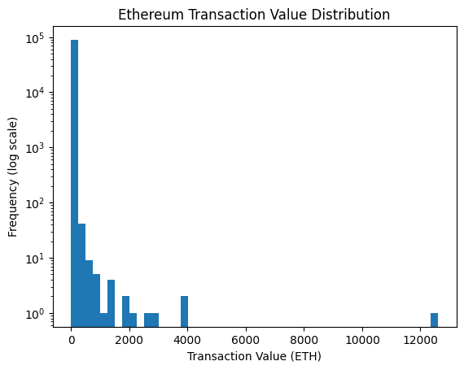
Fig 5:
Transaction Success vs Failure:
The majority of Ethereum transactions are successfully executed, with only a small proportion of failed transactions. The number of failed transactions remains low, but their impact is substantial since specific wallets show automated behavior through their continuous transaction failures. The failure rate serves as an essential factor for detecting both wallet-level anomalies and automated bot activities according to this insight.
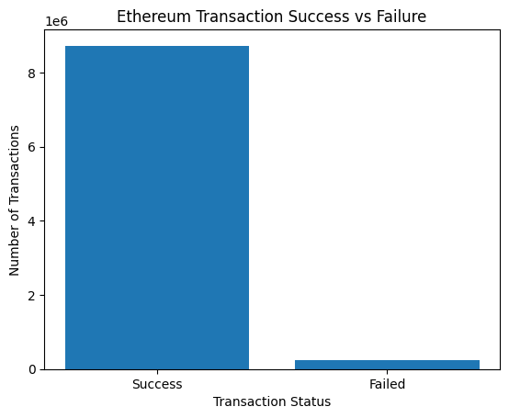
Fig 6:
Gas Limit vs Gas Used:
The majority of transactions consume less gas than their designated gas limit which shows that users under control their gas spending. The gas usage of transactions that reach their gas limit demonstrates their complicated execution process and serves as a valuable tool for detecting system anomalies.
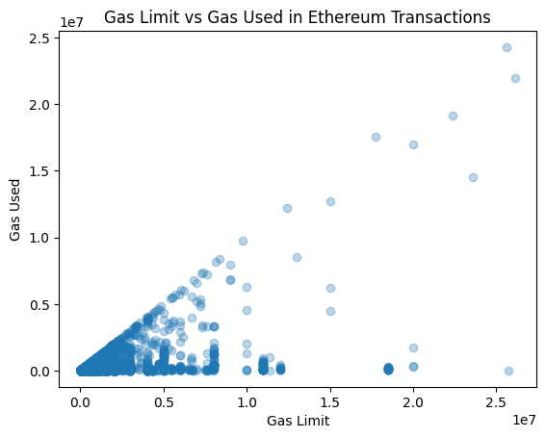
Fig 7:
11.2. Transaction-Level Anomaly (Whale Transactions):
The researchers examined transactions which exceeded 1000 in ETH value to locate whale activities. The histogram shows that such high-value transfers are rare and highly concentrated, confirming their anomalous nature and justifying their use as transaction-level anomalies in the analysis.
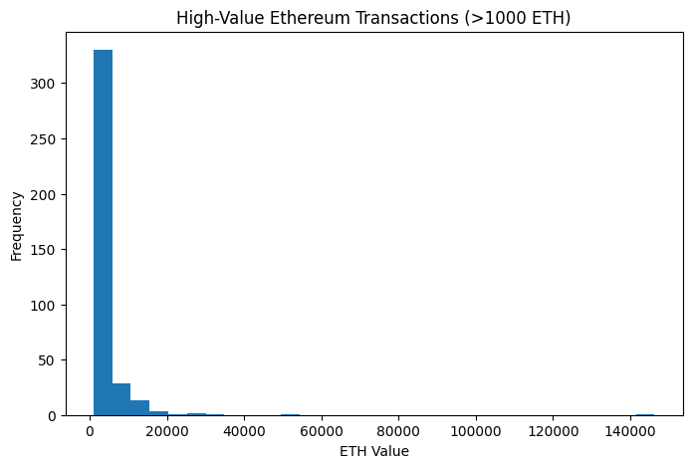
Fig 8:
11.3. Failed Transaction Analysis (Wallet-Level Anomaly):
The study finds the top wallets with the most unsuccessful transactions. Wallets that consistently fail transactions differ from regular user behavior and may suggest automated bots, erroneous contract interactions, or malicious probing operations. As a result, these wallets are classified as wallet-level abnormalities, and they help the system detect fraud and activity.
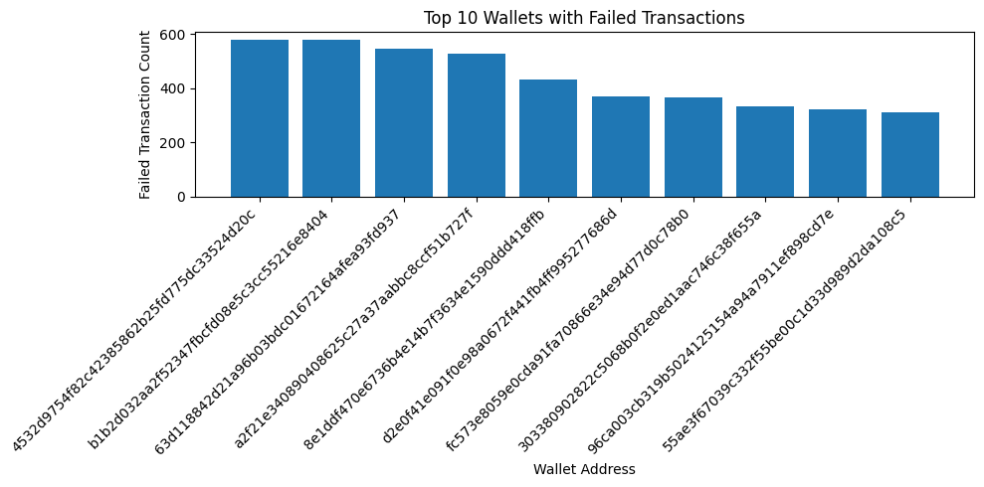
Fig 9:
11.4. Address level Behavior:
Wallet-level feature aggregation identifies a limited number of wallets with extremely high transaction counts. These high-frequency wallets differ dramatically from normal user behavior and might be automated agents, exchange-related accounts, or suspicious high-activity organizations. The transaction count was thus employed as a crucial behavioral signal for detecting potential wallet-level irregularities.
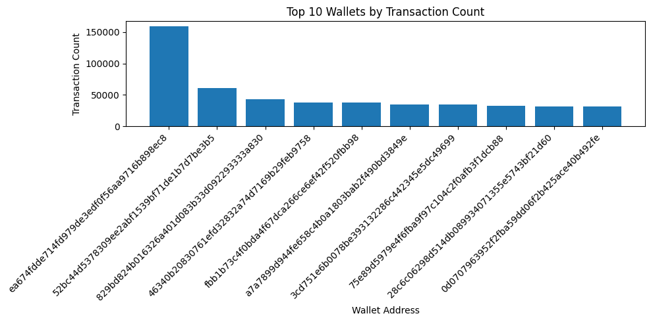
Fig 10:
11.5. Bot Wallet Detection:
Bot wallets were found as having a very high transaction frequency but an abnormally low average transaction value. These wallets display automated behavior patterns that differ considerably from regular user activity, proving their status as bot-driven wallet abnormalities.
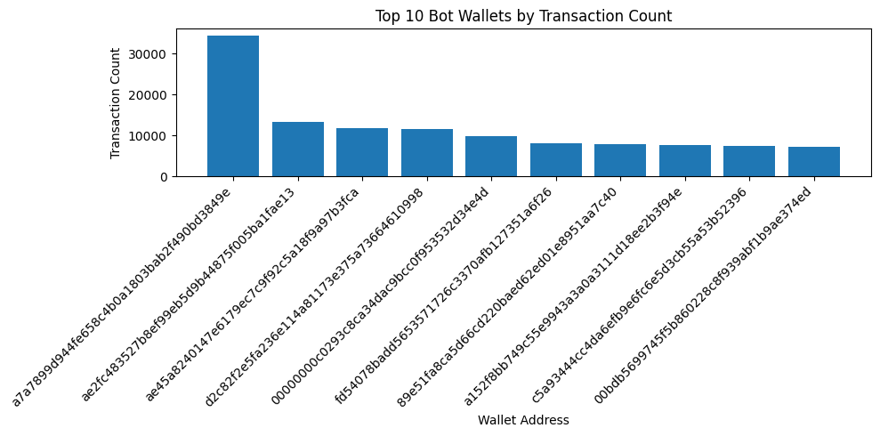
Fig 11:
11.6. Wash Trading Indicator(Repeated Sender–Receiver Pair Analysis):
A limited proportion of wallet pairings have very large repeat transactions, indicating anomalous interaction patterns. Frequent bidirectional transfers between the same sender and receiver are strong evidence of wash trading or coordinated conduct, hence they were classified as pair-level transactional anomalies.
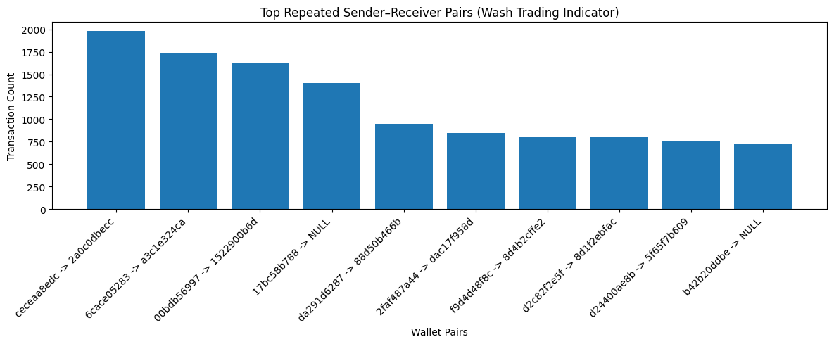
Fig 12:
11.7. Wash Trading Wallet Detection (Circular Transactions):
Wallets that perform circular transactions (A → B → A) were recognized as possible wash trading wallets. A high number of such circular transfers shows self-trading or coordinated money movement, which is often related with market manipulation and fake volume production. Wallets with the greatest circular trade counts were therefore identified as wash trading anomalies.
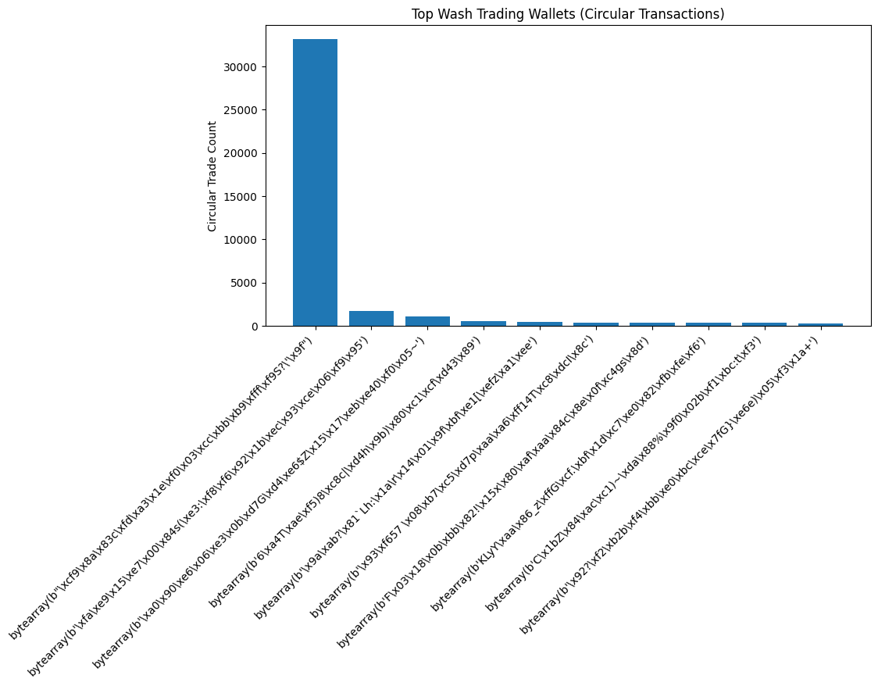
Fig 13:
11.8. Isolation Forest–Based Anomaly Detection:
Wallet-Level Anomalies: Isolation Forest was used to analyze aggregated wallet data (transaction count, average ETH value, failure rate, and gas variation). The program effectively identified a tiny sample of wallets with anomalous behavioral patterns, classifying them as suspicious wallets that differ considerably from regular transaction behavior.
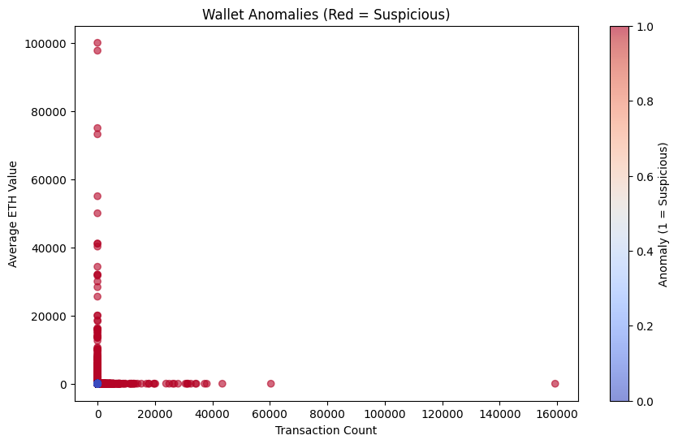
Fig 14:
11.9. Block-Level Anomalies:
At the block level, Isolation Forest was utilized to calculate average gas use, base charge, transaction count, and gas utilization. The model identified blocks with anomalous activity intensity and gas behavior, which might indicate network congestion, odd execution patterns, or coordinated transaction bursts.
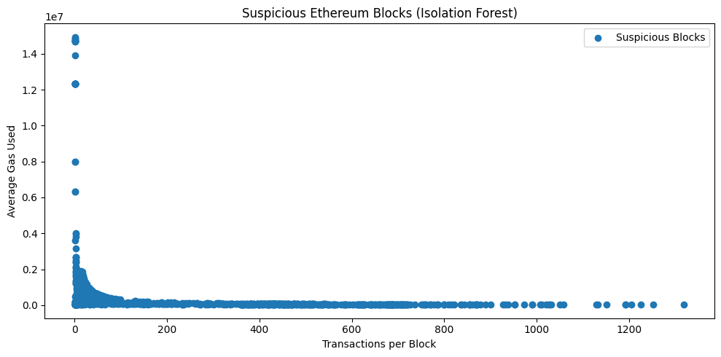
Fig 15:
11.10. Autoencoder-based anomaly detection:
The autoencoder-based anomaly detection discovered a limited number of wallets with significant reconstruction error, indicating unusual transaction behavior in terms of transaction count, value, failure rate, and gas variance. These wallets are marked as possibly suspicious owing to their departure from regular patterns.
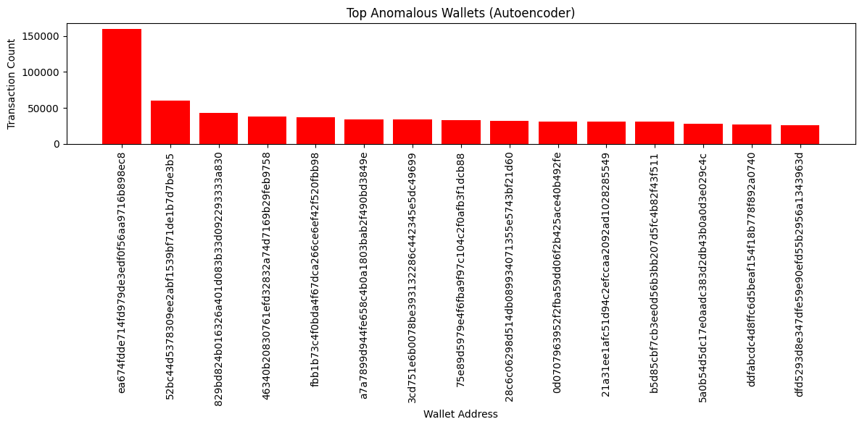
Fig 16:
11.11. Money Laundering Patterns:
Graph-based analysis found money laundering signs. Smurfing detection found wallets that were performing a large number of low-value transactions, which is a frequent obfuscation method. Cycle detection in the transaction graph revealed cyclic transfer patterns, indicating attempts to conceal financial origins.
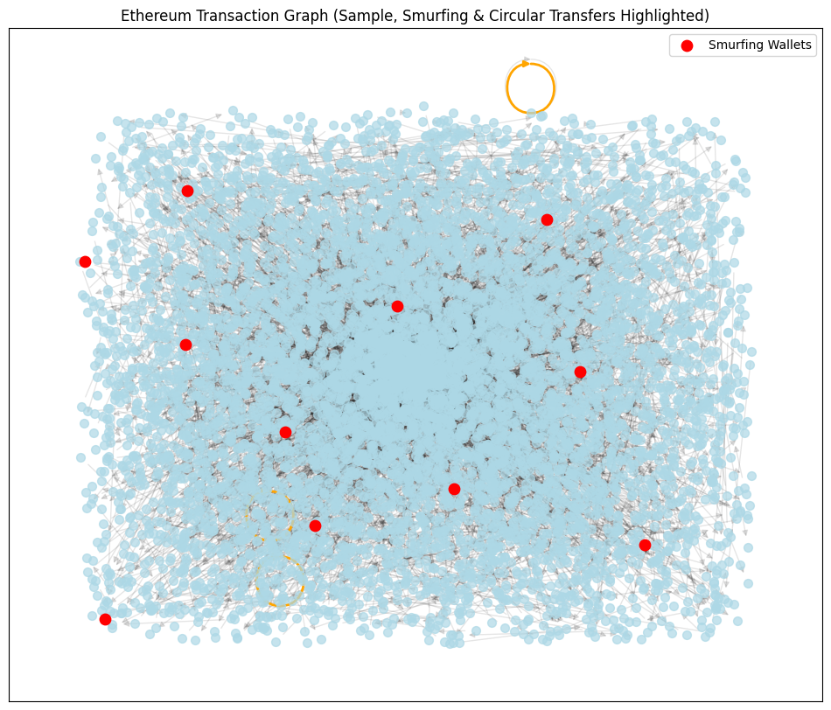
Fig 17:

11.12. Pump-and-dump Detection:
Time-based aggregation (10-minute windows) revealed abnormal spikes in transaction and ETH volume when compared to a 1-hour rolling baseline. Windows with sudden spikes in activity followed by sharp drops were identified as pump-and-dump events. The highlighted points in the plots confirm short-term market manipulation patterns characterized by sudden inflows and subsequent withdrawals of funds.
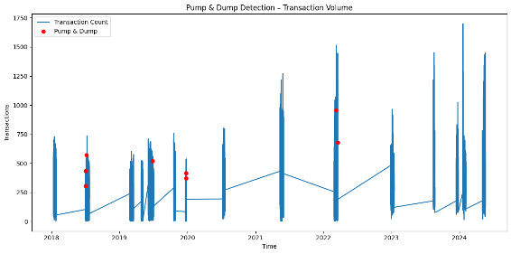
Fig 18:
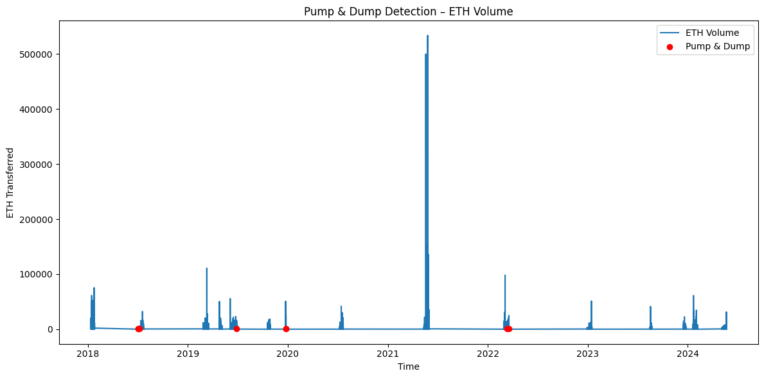
Fig 19:
FUTURE WORK
Future improvements to this work could include using temporal graph neural networks (GNNs) to better capture changing transaction patterns over time. Integrating real-time streaming analysis with frameworks like Spark Structured Streaming would enable the early detection of ongoing fraudulent activity. The use of multi-chain data (e.g., cross-chain bridges and DeFi protocols) can enhance the coverage of laundering activities. Additionally, incorporating adaptive thresholding and reinforcement learning may reduce false positives. Finally, working with on-chain labeling services and regulatory datasets can help validate detected anomalies and improve model accuracy.
CONCLUSION
This study presented a comprehensive framework for detecting suspicious activities in Ethereum transaction data by combining big data analytics and machine learning techniques. Multiple laundering and market manipulation patterns, including wash trading, circular transactions, smurfing, anomalous wallet behavior, and pump-and-dump schemes, have been successfully identified. Distributed processing with PySpark allowed for scalable feature extraction and aggregation, while graph-based analysis revealed complex transactional relationships. Furthermore, an autoencoder-based anomaly detection model successfully identified wallets with abnormal transactional behavior without requiring labeled data. The experimental results show that combining statistical analysis, graph theory, and deep learning yields a reliable and understandable approach to blockchain forensics and financial crime detection.
12. REFERENCES
[1] Y. Wu et al., “Behavior-aware Account De-anonymization on Ethereum Interaction Graph,” arXiv preprint arXiv:2203.09360, 2022.
[2] S. Patel et al., “Blockchain-based Fraud Detection: A Systematic Review of Ethereum Network Applications,” Cluster Computing, Springer, 2025.
[3] Y. Zhang et al., “Aparecium: Detecting Scam Behaviors on Ethereum via Biased Random Walk,” Cybersecurity, SpringerOpen, vol. 6, no. 1, 2023.
[4] R. Kumar et al., “Detection of Fraudulent Transactions in Ethereum Blockchain Smart Contracts Using Deep Learning,” Journal of King Saud University – Computer and Information Sciences, 2025.
[5] K. Reddy et al., “Intelligent Fraud Detection in Ethereum Transactions Using Machine Learning,” International Journal for Research in Applied Science and Engineering Technology (IJRASET), 2025.

13. APPENDIX
Installations:
!apt-get install openjdk-11-jdk-headless -qq
!pip install pyspark
!pip install findspark
!pip install -q huggingface_hub fsspec
!pip install -q pyspark huggingface_hub
Version Check:
import pyspark
print("PySpark version:", pyspark.__version__)
Spark Session Creation:
from pyspark.sql import SparkSession
spark = SparkSession.builder \
.appName("Ethereum Big Data Anomaly Detection") \
.config("spark.executor.memory", "4g") \
.config("spark.driver.memory", "4g") \
.getOrCreate()
print("Spark Session Created Successfully")
Data Loading:
from huggingface_hub import list_repo_files, hf_hub_download
import os
repo_id = "vnegi10/Ethereum_blockchain_parquet"
base_dir = "/content/eth_full_data"
os.makedirs(base_dir, exist_ok=True)
files = list_repo_files(repo_id=repo_id, repo_type="dataset")
print("Total files in dataset:", len(files))
for file in files:
if file.startswith("blocks/") or file.startswith("transactions/"):
hf_hub_download(
repo_id=repo_id,
filename=file,
repo_type="dataset",
local_dir=base_dir
)
Data Ingestion:
blocks_df = spark.read.parquet(
"/content/eth_full_data/blocks/*.parquet"
)
tx_df = spark.read.parquet(
"/content/eth_full_data/transactions/*.parquet"
)
Data Storage:
blocks_df = spark.read \
.option("ignoreCorruptFiles", "true") \
.parquet("/content/eth_full_data/blocks/*.parquet")
tx_df = spark.read \
.option("ignoreCorruptFiles", "true") \
.parquet("/content/eth_full_data/transactions/*.parquet")
blocks_df.describe().show()
tx_df.describe().show()
HDFS Layer:
blocks_df.write.mode("overwrite").parquet("/content/hdfs/blocks")
tx_df.write.mode("overwrite").parquet("/content/hdfs/transactions")

print("Data stored in Hadoop-style Parquet format")
Data Integration:
from pyspark.sql.functions import col
# Select block-level features
blocks_sel = blocks_df.select(
"block_number",
"timestamp",
col("gas_used").alias("block_gas_used"),
"base_fee_per_gas"
)
# Select transaction-level features
tx_sel = tx_df.select(
"block_number",
"from_address",
"to_address",
col("value_f64").alias("tx_value"),
"gas_limit",
"gas_used",
"gas_price",
"success"
)
# Join transactions with blocks
eth_df = tx_sel.join(blocks_sel, "block_number", "inner")
eth_df.show(5)
eth_df.printSchema()
Data Preprocessing:
from pyspark.sql.functions import col, count, when
def null_report(df):
df.select([
count(when(col(c).isNull(), c)).alias(c)
for c in df.columns
]).show(truncate=False)
print("Blocks null report")
null_report(blocks_df)
print("Transactions null report")
null_report(tx_df)
tx_clean = tx_df.dropna(
subset=[
"value_f64",
"gas_limit",
"gas_used",
"gas_price",
"from_address",
"to_address"
]
)

print("Before cleaning:", tx_df.count())
print("After cleaning:", tx_clean.count())
from pyspark.sql.functions import col
eth_clean = eth_df.fillna(0)
eth_clean = eth_clean.withColumn(
"is_failed",
(~col("success")).cast("int")
)
from pyspark.sql.functions import col
eth_feat = eth_clean.withColumn(
"eth_value", col("tx_value") / 1e18
).withColumn(
"tx_fee", col("gas_used") * col("gas_price")
).withColumn(
"gas_utilization", col("gas_used") / col("block_gas_used")
)
eth_feat.select(
"eth_value", "tx_fee", "gas_utilization"
).show(5, truncate=False)
eth_feat.select(
"eth_value", "tx_fee", "gas_utilization"
).describe().show()
eth_feat.select("eth_value") \
.sample(0.01) \
.toPandas() \
.hist(bins=50)
Transaction level Anomalies(whale transactions):
eth_feat.filter(col("eth_value") > 1000).show(10, truncate=False)
import matplotlib.pyplot as plt
pdf_high = eth_feat.filter(col("eth_value") > 1000) \
.select(col("eth_value").cast("double")) \
.sample(0.2) \
.toPandas()
plt.figure(figsize=(8,5))
plt.hist(pdf_high["eth_value"], bins=30)
plt.title("High-Value Ethereum Transactions (>1000 ETH)")
plt.xlabel("ETH Value")
plt.ylabel("Frequency")
plt.show()
from pyspark.sql.functions import when
eth_feat = eth_feat.withColumn(
"is_failed",
when(col("success") == False, 1).otherwise(0)
)
eth_feat.groupBy("from_address") \
.sum("is_failed") \
.withColumnRenamed("sum(is_failed)", "failed_tx_count") \
.orderBy(col("failed_tx_count").desc()) \
.show(10, truncate=False)
import matplotlib.pyplot as plt
# Convert Spark → Pandas safely
pdf_failed = eth_feat.groupBy("from_address") \
.sum("is_failed") \
.withColumnRenamed("sum(is_failed)", "failed_tx_count") \
.orderBy(col("failed_tx_count").desc()) \
.limit(10) \
.toPandas()
# Convert bytearray addresses to readable hex strings
pdf_failed["from_address"] = pdf_failed["from_address"].apply(
lambda x: x.hex() if isinstance(x, (bytes, bytearray)) else str(x)
)
# Create numeric x positions
x_pos = range(len(pdf_failed))
plt.figure(figsize=(10,5))
plt.bar(x_pos, pdf_failed["failed_tx_count"])
plt.xticks(x_pos, pdf_failed["from_address"], rotation=45, ha="right")
plt.title("Top 10 Wallets with Failed Transactions")
plt.ylabel("Failed Transaction Count")
plt.xlabel("Wallet Address")
plt.tight_layout()
plt.show()
Address level behaviour Profiles:
from pyspark.sql.functions import avg, count, variance, col
address_features = eth_feat.groupBy("from_address").agg(
count("*").alias("tx_count"),
avg(col("eth_value").cast("double")).alias("avg_value"),
avg(col("is_failed").cast("double")).alias("failure_rate"),
variance(col("gas_used").cast("double")).alias("gas_variance")
)
address_features.show(5, truncate=False)
import matplotlib.pyplot as plt
pdf_addr = address_features.orderBy(col("tx_count").desc()) \
.limit(10) \
.toPandas()
# Convert bytearray addresses
pdf_addr["from_address"] = pdf_addr["from_address"].apply(
lambda x: x.hex() if isinstance(x, (bytes, bytearray)) else str(x)
)
plt.figure(figsize=(10,5))
plt.bar(range(len(pdf_addr)), pdf_addr["tx_count"])
plt.xticks(range(len(pdf_addr)), pdf_addr["from_address"], rotation=45, ha="right")
plt.title("Top 10 Wallets by Transaction Count")
plt.ylabel("Transaction Count")
plt.xlabel("Wallet Address")
plt.tight_layout()
plt.show()
from pyspark.sql.functions import when
bot_wallets = address_features.withColumn(
"is_bot",
when(
(col("tx_count") > 1000) &
(col("avg_value") < 0.01),
1
).otherwise(0)
)
bot_wallets.select(
"from_address", "tx_count", "avg_value", "failure_rate", "is_bot"
).show(10, truncate=False)
detected_bots = bot_wallets.filter(col("is_bot") == 1)
print("Detected bot wallets count:", detected_bots.count())
detected_bots.show(10, truncate=False)
import matplotlib.pyplot as plt
pdf_bots = detected_bots.orderBy(col("tx_count").desc()) \
.limit(10) \
.toPandas()
pdf_bots["from_address"] = pdf_bots["from_address"].apply(
lambda x: x.hex() if isinstance(x, (bytes, bytearray)) else str(x)
)
plt.figure(figsize=(10,5))
plt.bar(range(len(pdf_bots)), pdf_bots["tx_count"])
plt.xticks(range(len(pdf_bots)), pdf_bots["from_address"], rotation=45, ha="right")
plt.title("Top 10 Bot Wallets by Transaction Count")
plt.ylabel("Transaction Count")
plt.xlabel("Wallet Address")
plt.tight_layout()
plt.show()
Block level Anomaly:
from pyspark.sql.functions import max
block_anomaly = eth_feat.groupBy("block_number").agg(
avg("gas_used").alias("avg_gas_used"),
max("block_gas_used").alias("block_gas_used"),
avg("base_fee_per_gas").alias("avg_base_fee"),
count("*").alias("tx_count")
).withColumn(
"block_gas_utilization",
col("avg_gas_used") / col("block_gas_used")
)
block_anomaly.show(5, truncate=False)
import matplotlib.pyplot as plt
pdf_block = block_anomaly.sample(0.01).toPandas()
plt.figure(figsize=(8,5))
plt.scatter(pdf_block["tx_count"], pdf_block["avg_gas_used"])
plt.xlabel("Transaction Count per Block")
plt.ylabel("Average Gas Used")
plt.title("Block Activity vs Gas Usage")
plt.tight_layout()
plt.show()
Isolation Forest Code:
from pyspark.sql.functions import avg, count, variance, col
# Aggregate features per wallet
wallet_features = eth_feat.groupBy("from_address").agg(
count("*").alias("tx_count"),
avg(col("eth_value").cast("double")).alias("avg_value"),
avg(col("is_failed").cast("double")).alias("failure_rate"),
variance(col("gas_used").cast("double")).alias("gas_variance")
).fillna(0)
wallet_features.show(5, truncate=False)
from sklearn.ensemble import IsolationForest
import matplotlib.pyplot as plt
# Collect wallet features to Pandas
pdf_wallet_features = address_features.select(
"tx_count", "avg_value", "failure_rate", "gas_variance", "from_address"
).toPandas()
# Run sklearn Isolation Forest
clf = IsolationForest(contamination=0.02, random_state=42)
clf.fit(pdf_wallet_features[["tx_count", "avg_value", "failure_rate", "gas_variance"]])
pdf_wallet_features["anomaly"] = clf.predict(
pdf_wallet_features[["tx_count", "avg_value", "failure_rate", "gas_variance"]]
)
# Convert sklearn labels: -1 = anomaly, 1 = normal
pdf_wallet_features["is_anomaly"] = (pdf_wallet_features["anomaly"] == -1).astype(int)
# Top 10 suspicious wallets
suspicious_wallets = pdf_wallet_features[pdf_wallet_features["is_anomaly"] == 1] \
.sort_values("tx_count", ascending=False).head(10)
plt.figure(figsize=(10,5))
plt.bar(range(len(suspicious_wallets)), suspicious_wallets["tx_count"])
plt.xticks(range(len(suspicious_wallets)), suspicious_wallets["from_address"], rotation=45, ha="right")
plt.title("Top 10 Suspicious Wallets (Isolation Forest)")
plt.ylabel("Transaction Count")
plt.xlabel("Wallet Address")
plt.tight_layout()
plt.show()
from sklearn.ensemble import IsolationForest
import matplotlib.pyplot as plt
from pyspark.sql.functions import col
# 1️ Collect features from Spark to Pandas
pdf_wallet_features = address_features.select(
"from_address", "tx_count", "avg_value", "failure_rate", "gas_variance"
).toPandas()
# 2️ Fit Isolation Forest
clf = IsolationForest(contamination=0.02, random_state=42)
clf.fit(pdf_wallet_features[["tx_count", "avg_value", "failure_rate", "gas_variance"]])

# 3️ Predict anomalies
pdf_wallet_features["anomaly"] = clf.predict(
pdf_wallet_features[["tx_count", "avg_value", "failure_rate", "gas_variance"]]
)
# 4️ Convert labels: -1 = anomaly, 1 = normal
pdf_wallet_features["is_anomaly"] = (pdf_wallet_features["anomaly"] == -1).astype(int)
# 5️ Filter suspicious wallets
wallet_anomaly = pdf_wallet_features
# 6️ Scatter plot: Transaction count vs ETH value
plt.figure(figsize=(10,6))
plt.scatter(
wallet_anomaly["tx_count"],
wallet_anomaly["avg_value"],
c=wallet_anomaly["is_anomaly"],
cmap="coolwarm",
alpha=0.6
)
plt.xlabel("Transaction Count")
plt.ylabel("Average ETH Value")
plt.title("Wallet Anomalies (Red = Suspicious)")
plt.colorbar(label="Anomaly (1 = Suspicious)")
plt.show()
Autoencoder Code:
import numpy as np
import pandas as pd
from sklearn.preprocessing import MinMaxScaler
from sklearn.neural_network import MLPRegressor
import matplotlib.pyplot as plt
# 1. Collect wallet features into Pandas
pdf_wallet = wallet_features.select(
"from_address", "tx_count", "avg_value", "failure_rate", "gas_variance"
).toPandas()
# Convert addresses to strings
pdf_wallet["from_address"] = pdf_wallet["from_address"].apply(
lambda x: x.hex() if isinstance(x, (bytes, bytearray)) else str(x)
)
# 2. Normalize features
features = ["tx_count", "avg_value", "failure_rate", "gas_variance"]
scaler = MinMaxScaler()
X_scaled = scaler.fit_transform(pdf_wallet[features])
# 3. Build Autoencoder (MLPRegressor)
autoencoder = MLPRegressor(hidden_layer_sizes=(8,4,8), max_iter=500, random_state=42)
autoencoder.fit(X_scaled, X_scaled) # Train to reconstruct input
# 4. Compute reconstruction error
X_pred = autoencoder.predict(X_scaled)
recon_error = np.mean(np.square(X_scaled - X_pred), axis=1)
pdf_wallet["recon_error"] = recon_error
# 5. Mark anomalies (top 2% error)
threshold = np.percentile(recon_error, 98)
pdf_wallet["anomaly"] = (pdf_wallet["recon_error"] >= threshold).astype(int)
# 6. Plot top anomalous wallets
anomalous_wallets = pdf_wallet[pdf_wallet["anomaly"]==1].sort_values("tx_count", ascending=False).head(15)
plt.figure(figsize=(12,6))
plt.bar(anomalous_wallets["from_address"], anomalous_wallets["tx_count"], color='red')
plt.xticks(rotation=90)
plt.xlabel("Wallet Address")
plt.ylabel("Transaction Count")
plt.title("Top Anomalous Wallets (Autoencoder)")
plt.tight_layout()
plt.show()
Money Laundering Patterns:
from pyspark.sql.functions import col, count, avg
import networkx as nx
import matplotlib.pyplot as plt
# -----------------------------
# Prepare edges for transactions
# -----------------------------
edges = eth_feat.select(
col("from_address").alias("src"),
col("to_address").alias("dst"),
col("eth_value"),
col("block_number")
).filter(col("eth_value") > 0)
# -----------------------------
# Detect Smurfing Wallets
# -----------------------------
smurfing = edges.groupBy("src").agg(
count("*").alias("tx_count"),
avg("eth_value").alias("avg_tx_value")
).filter((col("tx_count") > 50) & (col("avg_tx_value") < 0.1)) # threshold adjustable
print("Top 10 Smurfing Wallets:")
smurfing.show(10, truncate=False)
# Collect smurfing wallet addresses for highlighting
smurf_nodes = smurfing.select("src").rdd.flatMap(
lambda x: [x[0].hex() if isinstance(x[0], bytearray) else str(x[0])]
).collect()
# -----------------------------
# Build Transaction Graph (Sample for Visualization)
# -----------------------------
# -----------------------------
# Build Transaction Graph (Sample for Visualization)
# -----------------------------
pdf_edges = edges.limit(5000).toPandas() # limit for graph processing
G = nx.DiGraph()
for _, row in pdf_edges.iterrows():
src = row["src"].hex() if isinstance(row["src"], bytearray) else str(row["src"])
dst = row["dst"].hex() if isinstance(row["dst"], bytearray) else str(row["dst"])
G.add_edge(src, dst, weight=row["eth_value"])
# -----------------------------
# Detect Circular Transfers (Cycles)
# -----------------------------
cycles = list(nx.simple_cycles(G))
print(f"\nNumber of circular transfer cycles detected: {len(cycles)}\n")
# Prepare edges involved in cycles
cycle_edges = []
for cycle in cycles:
for i in range(len(cycle)):
cycle_edges.append((cycle[i], cycle[(i+1) % len(cycle)]))
# -----------------------------
# Filter nodes/edges for visualization
# -----------------------------
# Only include smurfing wallets present in the sampled graph
smurf_nodes_in_graph = [n for n in smurf_nodes if n in G.nodes()]
# Only include cycle edges that exist in the sampled graph
cycle_edges_in_graph = [(u, v) for u, v in cycle_edges if u in G.nodes() and v in G.nodes()]
# -----------------------------
# Visualize Transaction Graph
# -----------------------------
pos = nx.spring_layout(G, seed=42) # consistent layout

plt.figure(figsize=(12,10))
# Draw all nodes and edges lightly
nx.draw_networkx_nodes(G, pos, node_size=50, node_color='lightblue', alpha=0.7)
nx.draw_networkx_edges(G, pos, alpha=0.1)
# Highlight smurfing wallets
if smurf_nodes_in_graph:
nx.draw_networkx_nodes(
G, pos,
nodelist=smurf_nodes_in_graph,
node_size=80,
node_color='red',
label='Smurfing Wallets'
)
# Highlight circular transfers
if cycle_edges_in_graph:
nx.draw_networkx_edges(
G, pos,
edgelist=cycle_edges_in_graph,
edge_color='orange',
width=2,
label='Circular Transfers'
)
plt.title("Ethereum Transaction Graph (Sample, Smurfing & Circular Transfers Highlighted)")
plt.legend()
plt.show()
Pump and Dump Detection:
from pyspark.sql.functions import col, from_unixtime
eth_time = eth_feat.withColumn(
"event_time",
from_unixtime(col("timestamp")).cast("timestamp")
)
eth_time.select("event_time", "eth_value").show(5, truncate=False)
from pyspark.sql.functions import window, count, sum, avg
time_agg = eth_time.groupBy(
window(col("event_time"), "10 minutes")
).agg(
count("*").alias("tx_count"),
sum("eth_value").alias("total_eth"),
avg("eth_value").alias("avg_eth")
).orderBy("window")
time_agg.show(5, truncate=False)
pdf = time_agg.select(
col("window.start").alias("time"),
"tx_count",
"total_eth",
"avg_eth"
).toPandas()
pdf = pdf.sort_values("time")
pdf.head()
# 1 hour baseline = 6 × 10-minute windows
pdf["rolling_tx"] = pdf["tx_count"].rolling(6).mean()
pdf["rolling_eth"] = pdf["total_eth"].rolling(6).mean()
# Pump indicators
pdf["tx_spike"] = (pdf["tx_count"] - pdf["rolling_tx"]) / pdf["rolling_tx"]
pdf["eth_spike"] = (pdf["total_eth"] - pdf["rolling_eth"]) / pdf["rolling_eth"]
# Dump indicator (next window crash)
pdf["future_tx_change"] = pdf["tx_spike"].shift(-1)
pdf["pump_dump"] = (
(pdf["tx_spike"] > 1.5) & # sudden pump
(pdf["eth_spike"] > 1.5) & # high ETH inflow
(pdf["future_tx_change"] < -0.5) # sharp drop after
).astype(int)
pump_events = pdf[pdf["pump_dump"] == 1]
print(" Pump & Dump Events Detected:", len(pump_events))
pump_events[["time", "tx_count", "total_eth", "tx_spike", "eth_spike"]].head()
import matplotlib.pyplot as plt
plt.figure(figsize=(12,6))
plt.plot(pdf["time"], pdf["tx_count"], label="Transaction Count")
plt.scatter(
pump_events["time"],
pump_events["tx_count"],
color="red",
label="Pump & Dump",
zorder=3
)
plt.xlabel("Time")
plt.ylabel("Transactions")
plt.title("Pump & Dump Detection – Transaction Volume")
plt.legend()
plt.tight_layout()
plt.show()
plt.figure(figsize=(12,6))
plt.plot(pdf["time"], pdf["total_eth"], label="ETH Volume")
plt.scatter(
pump_events["time"],
pump_events["total_eth"],
color="red",
label="Pump & Dump",
zorder=3
)
plt.xlabel("Time")
plt.ylabel("ETH Transferred")
plt.title("Pump & Dump Detection – ETH Volume")
plt.legend()
plt.tight_layout()
plt.show()
Access Code: https://colab.research.google.com/drive/1x7aNkxWLtj92ZEWVTdjRiMJlrhEc0vrL?usp=sharing

